RhythmicTunes: Your Melodic Companion
Ideation Phase
Define the Problem Statements

Date | 5 March 2025
Team ID | SWTID1741243627158259
Project Name | Rhythmic tunes
Maximum Marks | 2 Marks
Team Details:
Team Leader: SHREE.V – vshreecs22.krmmc@gmail.com
Team member:DHANUSHREE.S – sdhanushreecs22.krmmc@gmail.com
Team member:KEERTHIGA.R – rkeerthigacs22.krmmc@gmail.com
Team member:PRITHIKANISHA.G – prithikanisha2003@gmail.com
Team member:LAKSHMINARASIMHAN.P.M – pmlakshminarasimhancs22.krmmc@gmail.com

Customer Problem Statement Template:
Create a problem statement to understand your customer's point of view. The Customer Problem Statement template helps you focus on what matters to create experiences people will love.
A well-articulated customer problem statement allows you and your team to find the ideal solution for the challenges your customers face. Throughout the process, you’ll also be able to empathize with your customers, which helps you better understand how they perceive your product or service.
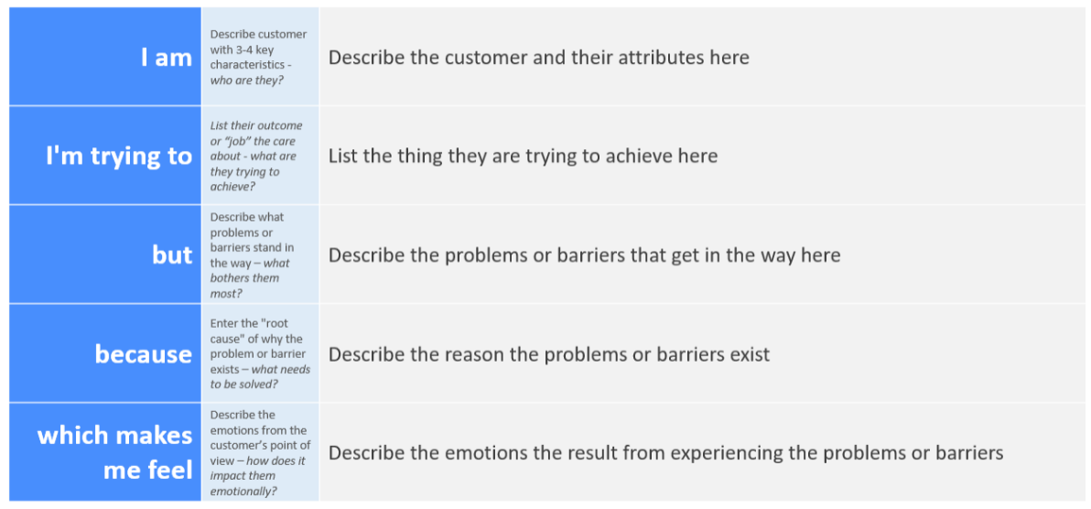
Reference: https://miro.com/templates/customer-problem-statement/
Example:

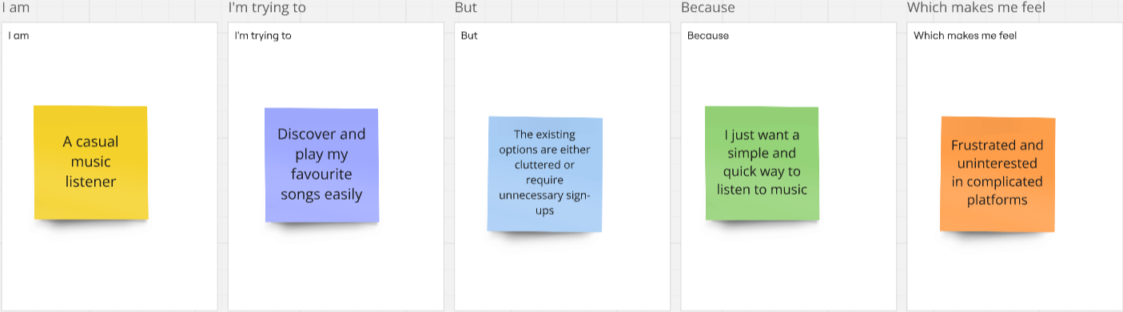

Problem Statement (PS) | I am (Customer) | I’m trying to | But | Because | Which makes me feel
PS-1 | A casual music listener | Discover and play my favourite songs easily | The existing options are either cluttered or require unnecessary sign-ups | I just want a simple and quick way to listen to music | Frustrated and uninterested in complicated platforms
PS-2 | A user exploring new music | Find new songs based on my preferences | Most platforms push mainstream tracks rather than personalized recommendations | I prefer fresh, unique music rather than what’s always trending | Disconnected from my personal taste and less excited about using the platform
PS-3 | A multitasker | Listen to music while working or studying | The platform has interruptions like ads or buffering issues | I need a seamless experience without distractions | Annoyed and frustrated with constant disruptions
PS-4 | A mobile user | Stream music on my phone with a smooth interface | The UI is not optimized for mobile or lacks essential features | I want a responsive and intuitive design that makes navigation easy | Frustrated and likely to switch to another app

